PCS Entitlements Reference Guide
By: Major Brennan Parker

Every time a Soldier moves, the military provides over twenty separate financial entitlements for reimbursement and compensation. Confusingly, information about PCS entitlements remains dispersed throughout many different regulations. To assist current and future Foreign Area Officers (FAOs), I compiled the Entitlements Quick Reference Guide to help FAOs focus on what matters during a PCS: beginning a new job and transitioning their family to a new locale. The DFAS Military Pay Policy team reviewed this article for accuracy prior to publication.
Table 1, the Entitlements Time Frames, depicts when in the lifecycle of a PCS claimable expenses occur. The table’s text colors specify under which situation the entitlement applies. The table lists the entitlements for Temporary Lodging Expense and Temporary Lodging Allowance twice because their duration differs depending on the locations of the FAO’s previous and new duty stations.
Table 2, the Entitlement Quick Reference Guide, identifies the documents necessary to claim the entitlement and the amount payable. This spreadsheet also specifies each entitlement’s citation in the Joint Travel Regulation or Financial Management Regulation to assist FAOs if clarifying information is needed. This one-page guide serves as a great financial PCS checklist.
The final section is the Explanation of Entitlements. These five pages are available online and each entitlement is reviewed in further depth. This is available on the FAO Milsuite website (https://www.milsuite.mil/book/groups/army-foreign-area-officer-program/content?filterID=contentstatus%5Bpublished%5D~category%5Bcompensation%5D).
While FAOs will have encountered many PCS entitlements up to this point in their careers, pays like the Civilian Clothing Allowance (CCA), Overseas School Tuition, Move-in Housing Allowance (MIHA), and Funded Environmental and Morale Leave (FEML) may be new. My hope in drafting this article is that FAOs and their families receive every entitlement they have earned.

Table 1. Entitlement Time Frames.
Table 2. Entitlements Quick Reference Guide.
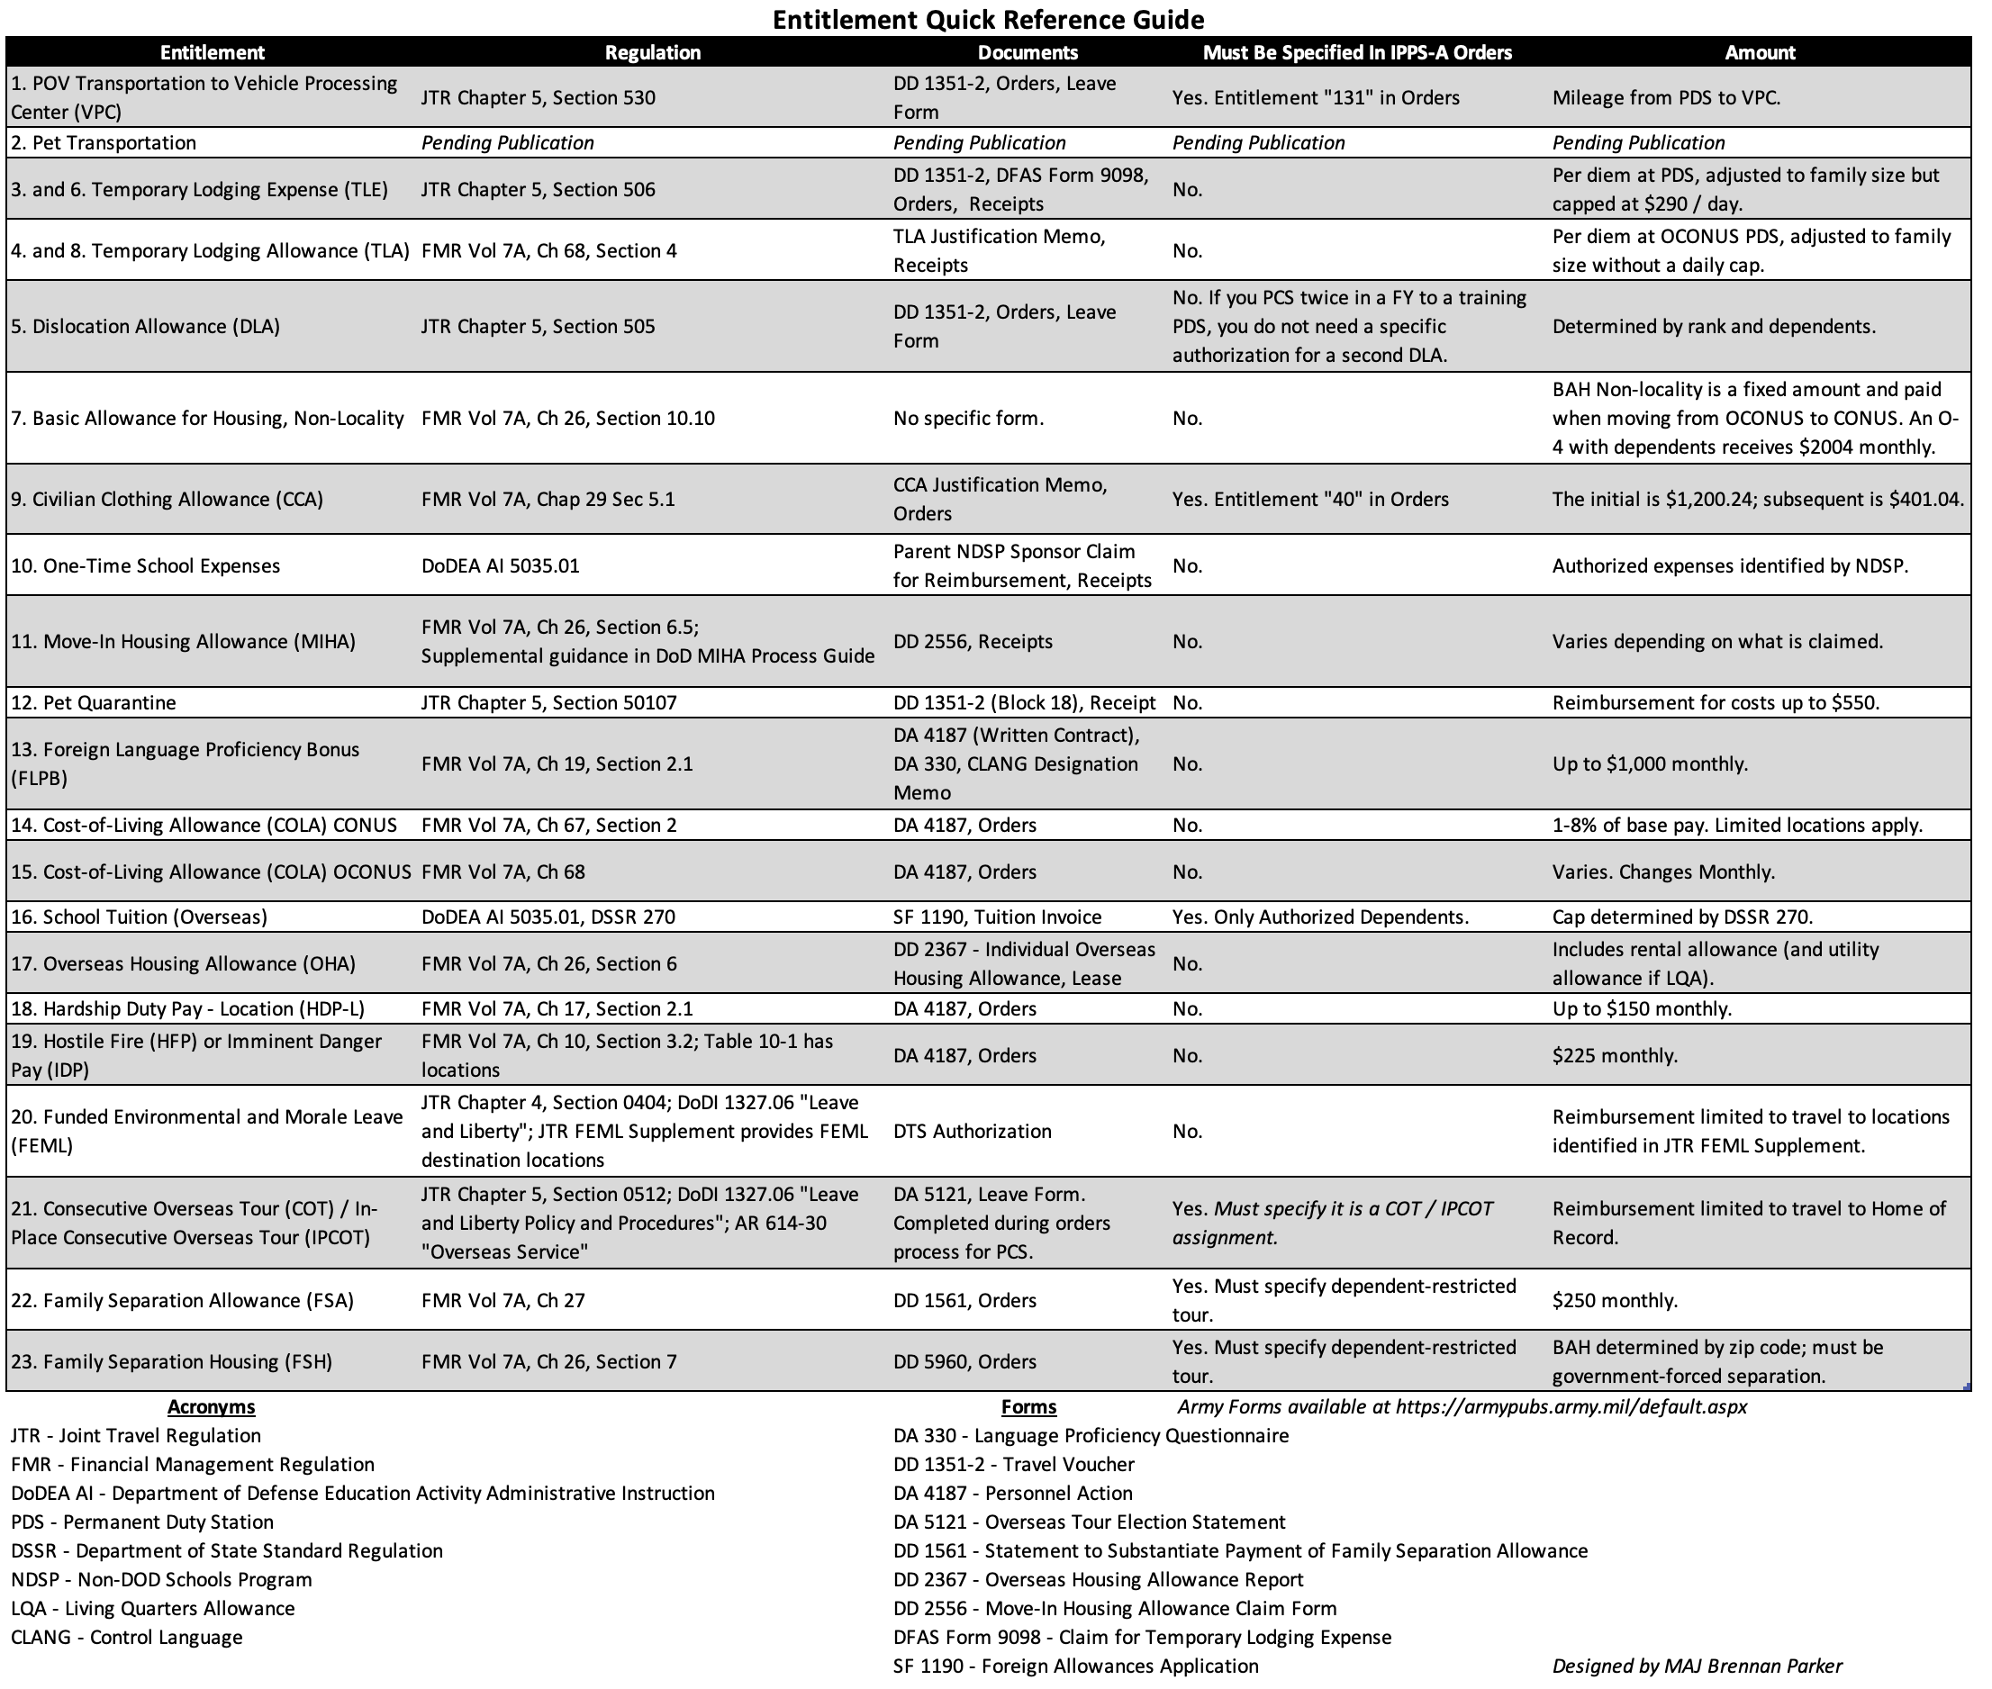
Explanation of Entitlements
Transit: Previous Duty Station
1. Private Owned Vehicle Transportation to and from the Vehicle Processing Center
Joint Travel Regulation Chapter 5, Section 530
If a Soldier’s orders authorize vehicle transportation overseas, the service member receives compensation to drop or pick up their vehicle from the Vehicle Processing Center (VPC). This applies to officers moving CONUS to OCONUS or vice versa. The Defense Transportation Regulation Part IV Attachment K3 “Shipping your POV” (https://www.ustranscom.mil/dtr/part-iv/dtr_part_iv_app_k_3.pdf) provides additional guidance if FAOs encounter resistance with getting a POV shipment authorized.

2. Pet Transportation
Pending Publication
The 2023 National Defense Authorization Act approved reimbursement for certain pet-related travel expenses. Official policy has not been published as of the time of this writing.

3. and 6. Temporary Lodging Expenses (if old or new Permanent Duty Station is CONUS)
Joint Travel Regulation Chapter 5, Section 506
DFAS Explanation - https://www.dfas.mil/militarymembers/travelpay/armypcs/tle/
Service members moving from the CONUS to OCONUS receive Temporary Lodging Expenses, adjusted for family size, to provide housing and per diem with a maximum of $290 per day. If moving from CONUS to OCONUS, the JTR authorizes seven days of TLE. If the Soldier moves from CONUS to CONUS, they receive fourteen days. If moving OCONUS to CONUS, the JTR allows fourteen days.

4. Temporary Lodging Allowance (if previous Permanent Duty Station is OCONUS)
Financial Management Regulation Volume 7A, Chapter 68, Section 4
DTMO Explanation - https://www.travel.dod.mil/Allowances/Temporary-Lodging-Allowance/
Temporary Lodging Allowance only applies while OCONUS. This explanation is specific to TLA usage before departing an OCONUS duty station. The senior commander in the country can approve up to ten days of TLA immediately before departing the country, though exceptions exist for other uses of TLA. The local per diem rate at the permanent duty station determines the entitlement amount.

Transit: New Duty Station
5. Dislocation Allowance
Joint Travel Regulation Chapter 5, Section 505
The dislocation allowance reimburses service members for costs associated with moving. The JTR authorizes one DLA payment each fiscal year, though circumstances may allow a second DLA payment in the same fiscal year (FY). The PCS to the Joint Military Attaché School (JMAS) or In-Region Training often necessitates two PCSes in the same FY. JTR 050501.B lists circumstances that allow a second DLA payment within the same FY. The service member’s rank and dependent status determine payment.

7. Basic Allowance for Housing – Transition
Financial Management Regulation Chapter 26, Section 10.10
The BAH-Transit category only applies when moving from OCONUS to CONUS. This is a fixed amount of BAH paid while a Service Member travels between permanent duty stations. When a Service Member signs out of a post where they received Overseas Housing Allowance (OHA), BAH-Transit provides a housing allowance until reporting to their new PDS. As an example, an O-4 with dependents receives $2,000.04 monthly.

8. Temporary Lodging Allowance (if new PDS is OCONUS)
Financial Management Regulation Volume 7A, Chapter 68, Section 4
Upon arrival overseas, Soldiers qualify for TLA. The senior commander in the country can approve TLA in 15-day increments as long as the service member pursues housing—and awaiting a house in the Embassy Housing Pool counts as pursuing housing. Unlike the ten-day limit associated with TLA when leaving an OCONUS PDS, arrival TLA does not have a limit. TLA ends when the service member receives their house and household goods. The local per diem rate at the permanent duty station determines the entitlement amount.

9. Civilian Clothing Allowance
Financial Management Regulation Volume 7A, Chapter 29, Section 5.1
DoD Instruction 1338.18 Armed Forces Clothing Monetary Allowance Procedures
Army Regulation 700-84 Issue and Sale of Personal Clothing, Chapter 8
Officers receive an initial civilian clothing allowance when stationed OCONUS in a job that requires civilian clothing worn at least half the time. The entitlement is $1,171.80 in FY23. After the first year in a CCA-authorized assignment, officers receive a “maintenance” clothing allowance annually, which is $390.60 in FY23. This entitlement must be in the Soldier’s orders. Some jobs CONUS may qualify for the CCA.

10. One-Time School Expenses
Department of Defense Education Activity Administrative Instruction 5035.01
The Non-DOD Schools Program (NDSP) reimburses the service member for one-time school expenses related to registration. Allowable expenses include application fees, transcript translation fees, birth certificates, and matriculation fees. Non-allowable expenses include school meals, school uniforms, some elective courses, and electronic devices. The NDSP website further outlines allowable and non-allowable costs. The NDSP covers fees once per tour, so if a Soldier changes schools for their dependents mid-year, additional fees incurred are paid out-of-pocket.

11. Move-In Housing Allowance
Financial Management Regulation Volume 7A, Chapter 26, Section 6.5
Supplemental Guidance in DoD MIHA Process Guide
For officers receiving Overseas Housing Allowance (OHA), the Move-In Housing Allowance (MIHA) reimburses service members for expenses incurred when occupying a home. Items must be necessary to make the house habitable. MIHA provides four reimbursement categories: miscellaneous, rent, security, and infectious disease precautions. Table 26-24 in the FMR Vol 7A, Chapter 26 outlines typical expenses that qualify for MIHA reimbursement. Reportable MIHA expenses that fall under the miscellaneous category include: burglar alarms, security upgrades, water purification filters, appliances (range, refrigerator, freezer, washer, or dryer), air conditioners, and transformers. MIHA does not cover safety upgrades to the dwelling. Each locality has a different MIHA expense ceiling.

12. Pet Quarantine
Joint Travel Regulation Chapter 5, Section 50107
If local laws mandate a quarantine for household pets, defined as a cat or dog by the JTR, then a Service Member may claim up to $550 per PCS. This is separate from the pet transportation fees.

Enduring Pays and Entitlements
13. Foreign Language Proficiency Bonus
Financial Management Regulation, Volume 7A, Chapter 19, Section 2
DoD Instruction 1340.2 Military Foreign Language Skill Proficiency Bonuses, Section 3
Army Regulation 11-6 Army Foreign Language Program, Chapter 4
Overview: https://www.hrc.army.mil/content/Foreign%20Language%20Proficiency%20Bonus
The overseas recertification process is the only aspect of FLPB pay that changes while overseas. Instead of the annual certification, the service member can request an extension from their Senior Defense Official to extend FLPB certification for 24 months when a testing center is unavailable. The monthly limit remains $1,000, though MILPER 23-069 authorizes pay by-modality.

14. CONUS Cost-of-Living Allowance
Financial Management Regulation Volume 7A, Chapter 67, Section 2
DTMO Calculator - https://www.travel.dod.mil/Allowances/CONUS-Cost-of-Living-Allowance/
As of the time of writing, four CONUS military housing areas (MHAs) qualify for COLA. By law, the cost of non-housing goods and services must be at least eight percent more expensive than the national average to qualify for COLA. The MHAs in San Francisco, Detroit, New York City / Staten Island, Martha’s Vineyard, and Essex County / Hampden County in Massachusetts receive COLA.

15. OCONUS Cost-of-Living Allowance
Financial Management Regulation, Volume 7A, Chapter 68
DTMO Calculator - https://www.travel.dod.mil/Allowances/Overseas-Cost-of-Living-Allowance/Overseas-COLA-Rate-Lookup/
OCONUS COLA is an entitlement that equalizes the purchasing power of a service member to acquire the same level of goods and services overseas. Overseas COLA varies monthly based on exchange rate fluctuations, the Living Pattern Survey, and the Retail Price Schedule. COLA begins the day the service member reports to a new permanent duty station and ends the day before departure.

16. School Tuition and Transportation
Department of Defense Education Activity Administrative Instruction 5035.01
The Department of Defense funds school tuition and transportation for authorized dependents up to the Department of State Standardized Regulation (DSSR) 270 limit for the country. This is often tens of thousands of dollars per child. The NDSP website also outlines allowable home-school expenses. The Department of State Office of Allowances provides a database for the Education Allowance in each locale.

17. Overseas Housing Allowance
Financial Management Regulation, Volume 7A, Chapter 26, Section 6
OHA Calculator - https://www.travel.dod.mil/allowances/overseas-housing-allowance/oha-rate-lookup/
The Overseas Housing Allowance covers the actual cost for the Service Member when government-leased or government-owned housing is provided. This is colloquially known as the “housing pool.” If the Soldier is not in government-leased or government-owned housing, then the Soldier receives a Living Quarters Allowance (LQA). For LQA recipients, the monthly amount includes rental costs and a utility/maintenance allowance paid directly to the Service Member.

18. Hardship Duty Pay – Location
Financial Management Regulation, Volume 7A, Chapter 17, Section 2
DFAS Location List - https://www.dfas.mil/militarymembers/payentitlements/Pay-Tables/HDP_L/
Service Members assigned to locations where living conditions are markedly below those in the Continental United States receive Hardship Duty Pay – Location. The amount varies from $50-$150 monthly and is pro-rated. Many countries qualify for HDP-L payment. The entitlement begins immediately upon arrival for Soldiers on PCS orders to a country or after 30 days in the country if on TDY orders.

19. Hostile Fire or Imminent Danger Pay
Financial Management Regulation, Volume 7A, Chapter 10, Section 3.2; Table 10-1 has locations.
Imminent Danger Locations - https://www.dfas.mil/militarymembers/payentitlements/Pay-Tables/IDP-Areas/
A Service Member receives either Hostile Fire (HF) or Imminent Danger Pay (IDP) when assigned to an area officially designated as HF or IDP area. The maximum monthly amount is $225. Thirty-seven countries currently qualify for IDP or HF.

20. Funded Environmental and Morale Leave
Joint Travel Regulation Chapter 4, Section 0404; JTR FEML Supplement provides locations.
Service Members and their command-sponsored dependents, assigned overseas for at least twenty-four months to isolated, austere, or unhealthful locations, receive government-funded transportation from the Funded Environmental and Morale Leave (FEML) location to CONUS. Members assigned to a 36-month tour may qualify for two separate trips. Without authorization, FEML leave cannot be used during a tour's first or last six months. The JTR FEML supplement provides locations that qualify for FEML. Service members may travel to a different location, but their reimbursement is limited to the FEML location’s cost.

21. Consecutive Overseas Tour / In-Place Consecutive Overseas Tour
Joint Travel Regulation Chapter 5, Section 0512;
AR 614-30 “Overseas Service”
If assigned overseas and ordered to a second overseas tour, the service member and their family qualify for Consecutive Overseas Tour (COT), or In-Place Consecutive Overseas Tour (IPCOT) leave travel (JTR Table 5-25 outlines complete eligibility requirements). The government funds travel between their old permanent duty station and their Home of Record (HOR). Reimbursement to other locations is limited to the cost of travel to the HOR. COT leave must be pre-approved and specified on the Absence Request (formerly DA31) under Absence Type “Chargeable Absence, Reason 06” - COT. Additionally, Soldiers cannot defer COT leave unless they are supporting contingency operations.

22. Family Separation Allowance
Financial Management Regulation, Volume 7A, Chapter 27
If the government forces the service member to serve at a duty station away from their family for more than thirty days, they are entitled to Family Separation Allowance – Restricted (FSA-R). The monthly entitlement is $250.

23. Family Separation Housing
Financial Management Regulation, Volume 7A, Chapter 26, Section 7
The Family Separation Housing (FSH) allowance compensates Service Members for additional housing expenses from assignment to a permanent duty station overseas that is either unaccompanied, a dependent-restricted tour, or an area where dependent travel was denied or deferred. A Service Member qualifies for FSH-OCONUS at a monthly amount up to the without-dependents OHA rate for the PDS. The Service Member receives BAH for the prior duty station or for the location where dependents reside if they were moved at government expense.

